Shared the data in Looker Studio(BI report)

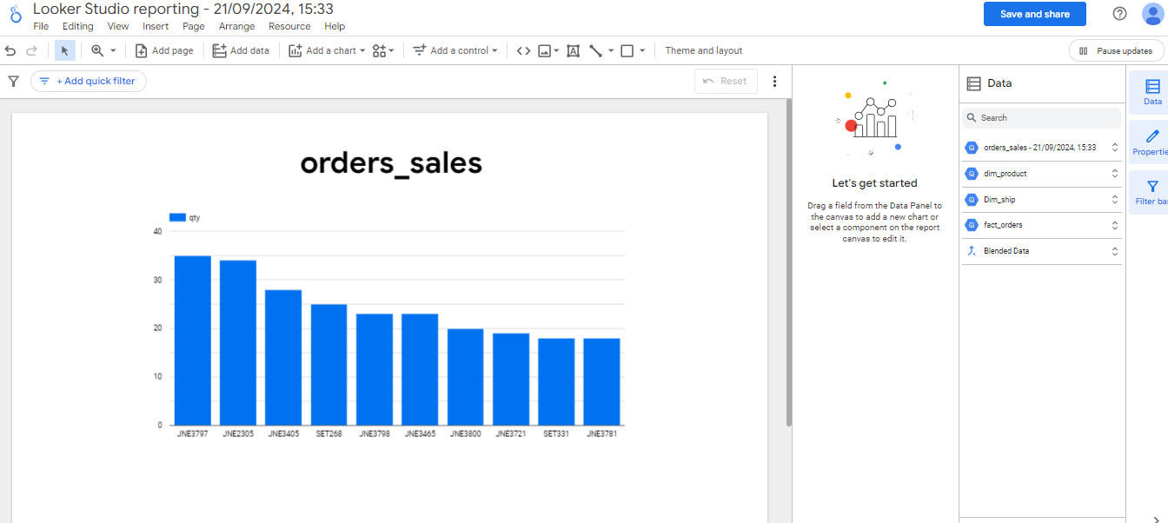

Joining of different tables in Looker studio

